Comtrol DeviceMaster Installation/Update Procedure

This manual contains the steps necessary to completely remove all traces of an existing Comtrol DeviceMaster driver, to update all files used with the DeviceMaster and to configure and test a DeviceMaster product.
This document does not include instructions for configuring security in the DeviceMaster.

This manual will show step-by-step instructions for this procedure when using the Microsoft Operating Systems of WindowsXP to Windows2012. The same instructions and files are used in all of these versions of the Operating System in both 32bit and 64bit systems. Please note that there may be minor screen shot differences, but these should not be severe enough to cause any discomfort. Screen shots may not show current versions.

This manual contains no explanations for the procedures outlined here.
For full information and details, please see the DeviceMaster user guides (http://downloads.comtrol.com/dev_mstr/rts/docs/dev_mstr_install_guide.pdf) and the DeviceMaster NS-Link user guide (http://downloads.comtrol.com/dev_mstr/rts/docs/devicemaster_windows_mgmt_console_userguide.pdf).

Keep in mind that whenever a system is changed, it is always a good idea to have a restore point or full backup for recovery purposes should something undesirable take place. See your Microsoft documentation for instructions on backing up your registry and/or system hard drive.

When removing your DeviceMaster with the intent of reinstalling (not simply updating) the drivers, start by getting the following basic information from each DeviceMaster found in Windows DeviceManager>Multi-port serial adapters. 1) The MAC address, 2) The IP address and 3) The com numbers assigned with the appropriate ports settings. This information will be used to configure the new drivers to maintain the same MAC, IP and port settings to avoid having to re-arrange serial cables or change settings in your application. Updating an existing driver will not interfere with these settings. It is highly recommended NOT to use the update procedure with drivers prior to version 10.XX due to the new features in this driver/firmware combination. Instead, removal of pre-existing drivers and a fresh install of this driver is strongly recommended.

Please note: Screen shots showing version numbers may not be correct and are shown as examples.

Files included in the Zip file: Description Extraction Location
Install_1206_package.docx These instructions in Microsoft Word format \1-Instructions
PortVision_DX_3.05.msi The PortVision DX installer \2-PortVision
PortVision_DX_4.09.msi The PortVision DX installer \2-PortVision
socketserver-11.30.cmtl SocketServer/NS-Link firmware \3-Binaries\SocketServer
Firmware_ReadMe.txt Describes SocketServer/NS-Link firmware \3-Binaries\SocketServer
bootloader-4.31.cmtl The Bootloader firmware \3-Binaries\Bootloader
DeviceMaster_Windows_12.06.exe Legacy IPv4-only driver installer \4-Driver
DeviceMaster_Windows_WSK_3.02.exe Current IPv4/IPv6 driver installer \4-Driver

Link to the package file containing all of the above:

http://downloads.comtrol.com/contribs/devicemaster/driver-packages/current/devicemaster_1206_package.zip

Chapters:
Chapter 1: PortVision DX Installation Page 2
Chapter 2: PortVision DX Discovery of DeviceMaster Page 5
Chapter 3: Configure the DeviceMaster’s IP information Page 7
Chapter 4: Setting the Bootloader Timeout Value in the DeviceMaster Page 10
Chapter 5: Updating the Firmware Page 11

Chapter 6: Resetting the Timeout Value in the DeviceMaster to 15 seconds Page 16

Chapter 7: Driver Wizard Installation Page 17
Chapter 8: Install a new Comtrol Device Page 19
Chapter 9: Update One or More DeviceMaster Drivers Page 22
Chapter 10: Remove all DeviceMaster Devices and Drivers Page 24
Chapter 11: Configure a DeviceMaster for Operation (Comtrol Mgmt Utility) Page 26
Chapter 12: Test your DeviceMaster Serial Ports Page 28
Chapter 13: Revision History Page 29

Document Version 12.06

PortVision DX Installation
Back to top

Which PortVision DX should be installed?
If this is a new installation of DeviceMaster units, install PortVision DX version 4.09
\2-PortVision\PortVision_DX_4.09.msi
If this is a new installation you may skip the rest of this page.

If this is a preexisting installation, and you currently have PortVision DX 3.05 running you may continue to use that version. Be aware that version 3.05 has reached its end of development and new products, as they become available, will not be discoverable using PortVision DX 3.05. With pre-existing DeviceMaster units installed in your environment, the recommendation is to update all DeviceMaster firmware using the Firmware files included in this package. Once the Firmware has been updated, uninstall PortVision DX version 3.05 and install the current PortVision DX version included in this package.
PortVision DX version 3.05 is also included in this package file at:
\2-PortVision\PortVision_DX_3.05.msi

What are the differences and why does this matter to me?
Microsoft is in the process of removing the OSI Layer 2 MAC protocol that has been used by Comtrol for years for discovery of DeviceMaster units in PortVision DX. This discovery protocol is being replaced with an OSI Layer 3 TCP/UDP discovery protocol. PortVision DX version 3.xx uses the older MAC mode discovery where PortVision DX version 4xx uses the new UDP discovery protocol.

There was also a change made to the Firmware that is loaded into the DeviceMaster to support the new UDP discovery protocol. This change was implemented in SocketServer version 10.00+ and Bootloader 4.22+. Both SocketServer and Bootloader still support the MAC mode discovery so will continue to work with PortVision DX 3.05. The only time that PortVision DX version 3.05 will be required is if your network has DeviceMaster units with Firmware version prior to version 10.00.

The current Firmware files included in this package are fully backwards compatible with all models of the DeviceMaster regardless of the age of the DeviceMaster.

Both versions of PortVision DX will have the same GUI look and feel and will operate the same from the user perspective. All of the changes are ‘under the hood’ and are changes to the way PortVision DX communicates directly to the DeviceMaster units.

If a previous version of PortVision Plus or PortVision DX prior to version 3.05 is currently installed, uninstall it by going to Control Panel>Add or Remove Programs. Select PortVision from the list and click on ‘Remove’. Close Add or Remove Programs. It will not be necessary to reboot. Now install the appropriate version included in this package.

For Pre-existing installations:
Run the PortVision_DX_3.05.msi (\devicemaster_1206_package\2-PortVision\ PortVision_DX_3.05.msi)

For new installations:
Run the PortVision_DX_4.09.msi (\devicemaster_1206_package\2-PortVision\ PortVision_DX_4.09.msi)

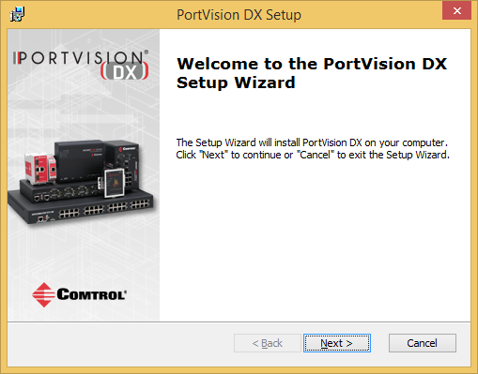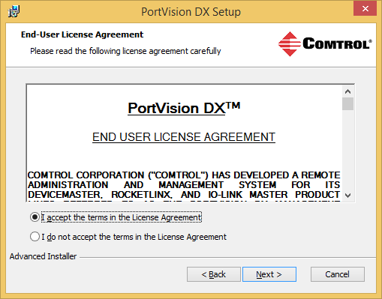
Select Next Select the "I accept…" and click 'Next'

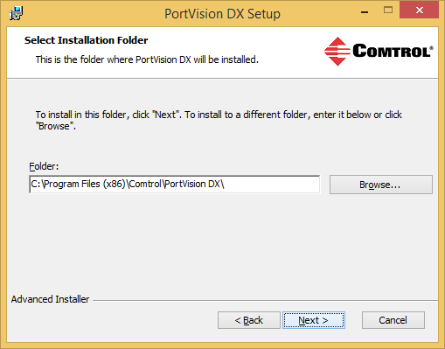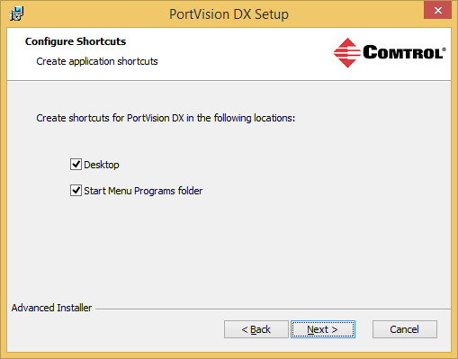
Accept the default and click 'Next' You will get the option to create a desktop shortcut and a
Start Menu Programs Folder.
Select Next

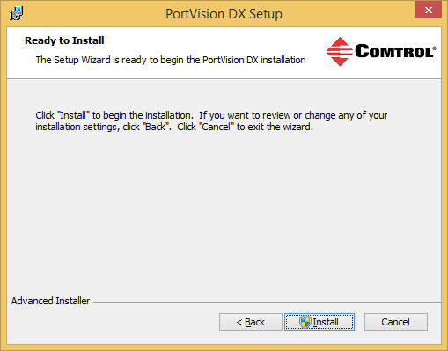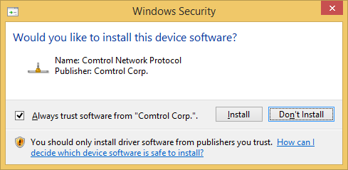
Select Install Select Install

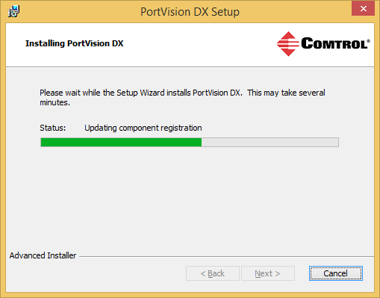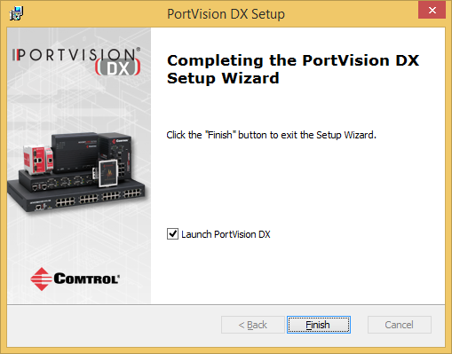
Files will now copy and the application will register itself Optionally select the Launch PortVision DX option.
to the system. Click Finish

If selected earlier, you will now have a PortVision DX icon on the desktop
You may launch PortVision DX by using the desktop icon or from the Start menu.

PortVision DX Discovery of DeviceMaster
Back to top

Connect the PC and the DeviceMaster(s) to the same switch whenever possible or connect an Ethernet patch cable directly from the NIC in the PC/laptop to the DeviceMaster. If the DeviceMaster has both an UP and DOWN Ethernet port, connect the patch cable to the UP port when connecting the DeviceMaster to a switch or to the DOWN port when direct connecting from the DeviceMaster to the PC.

Please note: Do not set any security options on the DeviceMaster until scanned into PortVision DX as doing so will prevent PortVision DX from being able to fully communicate or modify the settings for that DeviceMaster.

Please note: If you are already familiar with PortVision Plus, please note that PortVision DX is an all new application designed to work with and manage the complete line of Comtrol products. Later in this guide I will include a screen shot of some of the ways PortVision DX can display all of these other products. For full information and help with PortVision DX please see the user manual. In this guide we will be concerned with using it only with the DeviceMaster line of products.

Start PortVision DX
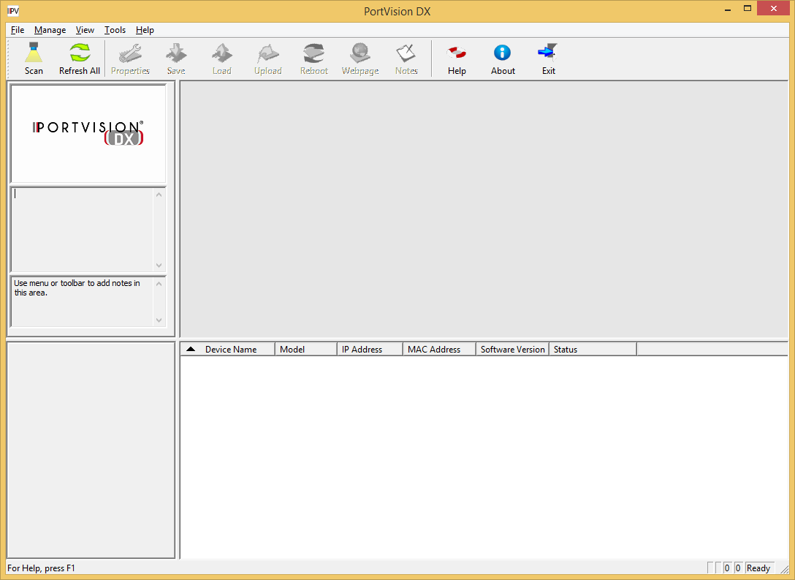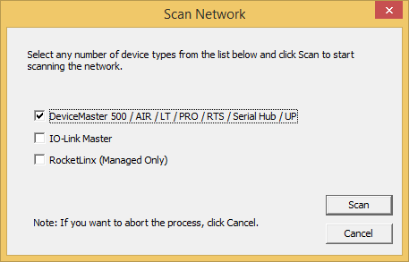
Device List Pane
Device Tree Pane
Select the “Scan” icon on launch bar. Select the desired products and Scan.

PortVision DX works with more than just DeviceMaster models. Comtrol’s IO-Link Master products and also Comtrol RocketLinx Switches can be managed in PortVision DX. Here we will be concerned only with DeviceMaster models, so we will select only the DeviceMaster 500 / AIR / LT / PRO /RTS / SerialHub / UP option as seen in the “Scan Network" dialog. If you have any of Comtrols switches or IO-Link Master products, please feel free to select them at this time.
Select “Scan”

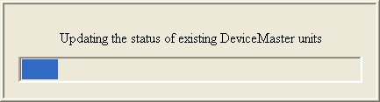
PortVision DX will now Scan for the different devices selected. Please be patient as this may take a couple of minutes depending on the types of Comtrol products selected and the number available on the network.

Your line item(s) may be slightly different depending on the hardware, version of software, IP address assigned, etc. Note the IP address. You will be using telnet to communicate to the DeviceMaster. The IP address must be compatible with the IP address assigned to the PC. If you do not see the DeviceMaster listed, click the “Scan” icon on the launch bar.

Click on the Scan Results [1/1] to have the DeviceMaster listed in the lower panel (Device List Pane) where all changes will take place. The DeviceMaster will also be listed in the hierarchy of the Scan Results [1/1] folder (Device Tree Pane) when the folder is expanded.
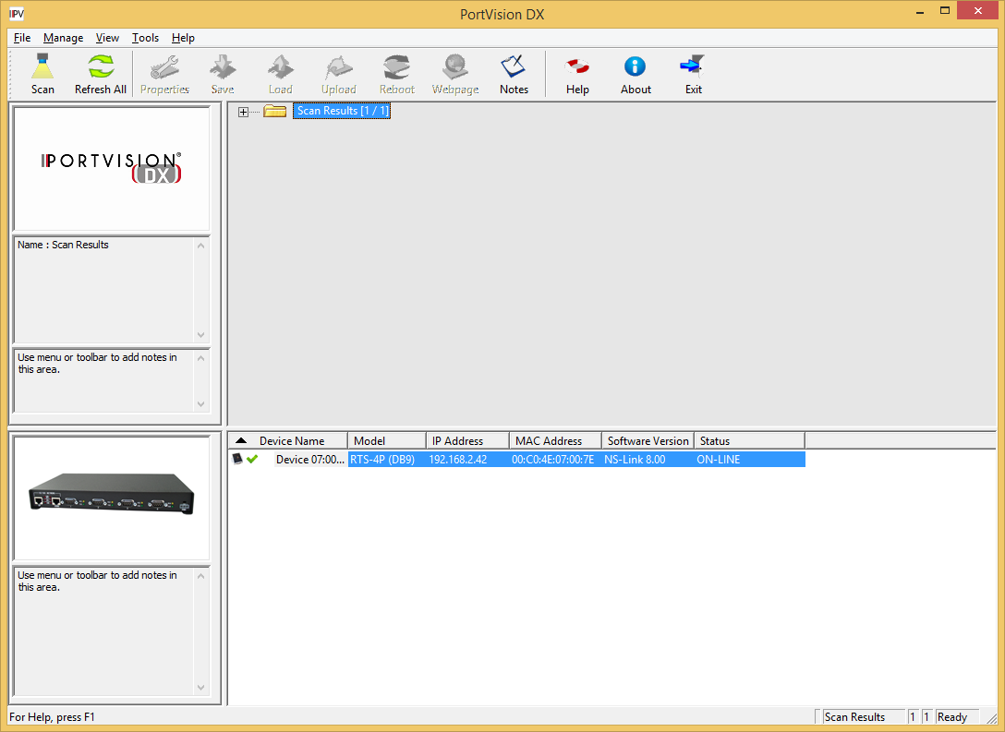
Device List Pane
Device Tree Pane
The graphic to the left of the Device List Pane will show a picture of the model of the device highlighted.
In the highlighted line you will see the major details of this DeviceMaster

Here we can see that this is a DeviceMaster RTS-4P (DB9) model with the default IP address. The MAC address is unique for every Comtrol and will always begin with 00:C0:4E.
This shows that it has an older version of SocketServer and should be updated to the current version. We can also see that the DeviceMaster status is ON-LINE. The ON-LINE is showing that the DeviceMaster is on the local Ethernet segment and was ‘discovered’ by PortVision DX.

If PortVision DX is unable to scan and discover the DeviceMaster, you may have a firewall blocking communications. See the Comtrol Forum for help with configuring firewalls. (http://forum.comtrol.com/index.php?t=tree&goto=26&#msg_26)
For additional assistance you may contact your Comtrol Technical Support Representative.

Configure the DeviceMaster’s IP information
Back to top

In the Device List Pane seen above, “Double Click” the DeviceMaster to open the Properties page.
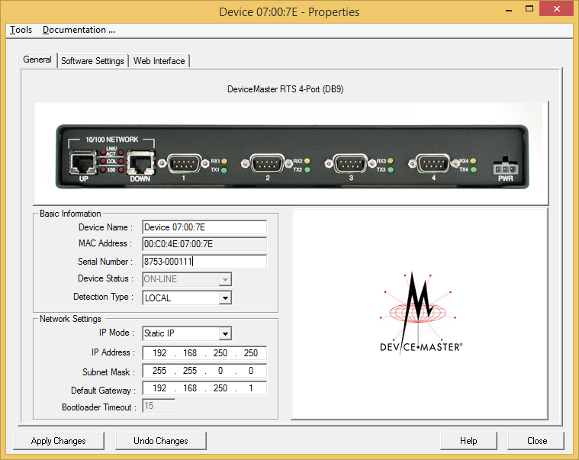
Here we will program a new IP address into the DeviceMaster.

Device name may be changed to something more user friendly such as the location the DeviceMaster will be placed.

You may manually enter the Serial Number of the DeviceMaster for future reference. The serial number is not discoverable by PortVision DX.

Local indicates that the DeviceMaster is on the same physical Ethernet segment as PortVision. Remote indicates that the DeviceMaster is on a remote network

IP Mode: This should be set to Static IP

Set the IP Address, Subnet Mask and Default Gateway to be compatible with your network. IP Communications will be required for later procedures.
Change the IP information to match to the desired network. In this example, the IP address to be used will be 192.168.2.42 as my PC has IP address 192.168.2.10. Once the values have been entered, select ‘Apply Changes’ and then select ‘Close’. The DeviceMaster will now reboot to set the new IP information.

The new IP address should now display and the DeviceMaster should show as ON-LINE once PortVision DX refreshes itself. PortVision DX only refreshes once every 120 seconds so you may want to click the launch bars’ “Refresh All” icon.
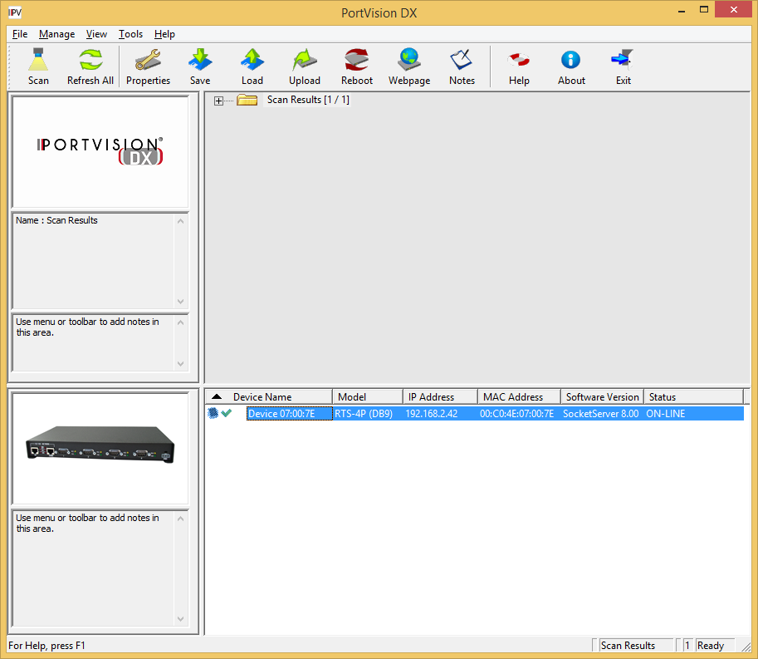
Device Tree Pane
Device List Pane

Note the details shown. The new IP address is now displayed. If any of the columns are blank, then PortVision DX is not in full communications with the DeviceMaster. If this should be the case, please call Comtrol Tech Support at 1-763-957-6000 and ask for your support representative.

This guide will not attempt to show the finer points of PortVision DX, but keep in mind that PortVision DX is very feature rich and has a very wide range of configuration possibilities.

Here is an example of how the author has designed his PortVision DX to look.
Here different folders have been created to hold particular models of products. These could as easily been to describe different locations.

One of the new features is the ability to add non-Comtrol products to the layout. I can now see what I have connected to the individual serial ports or Ethernet ports. In this case, I have added an Axis camera to one of my RocketLinx POE switches which is listed in the Device Tree Pane.

To get the full advantage and learn all of the features in PortVision DX it is recommended that you see the built in help. 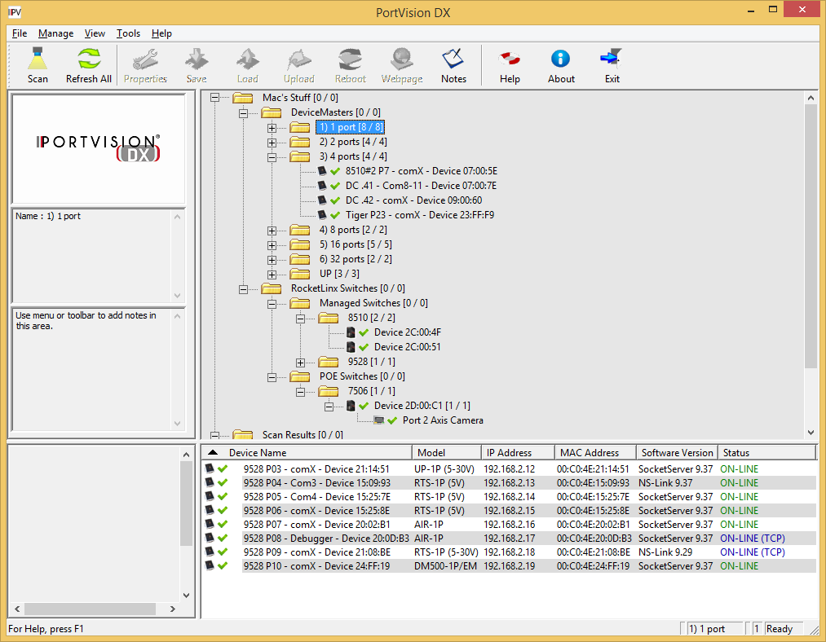
In this case the 1) 1port [8/8] folder is selected and the items in this folder are shown in the Device List Pane below.
One of the new features is the ability to add non-Comtrol products to the layout. I can now know what I have connected to the individual serial ports or Ethernet ports. In this case, I have added an Axis camera to one of my RocketLinx POE switches on Port 2.
I have renamed the devices so that the name means something to me.
Device List Pane
Device Tree Pane

Setting the Bootloader Timeout Value in the DeviceMaster
Back to top

Highlight the line item as shown (version numbers shown in screen shots may not be accurate)
The DeviceMaster MUST have valid TCP/IP communications from PortVision DX at this point forward.
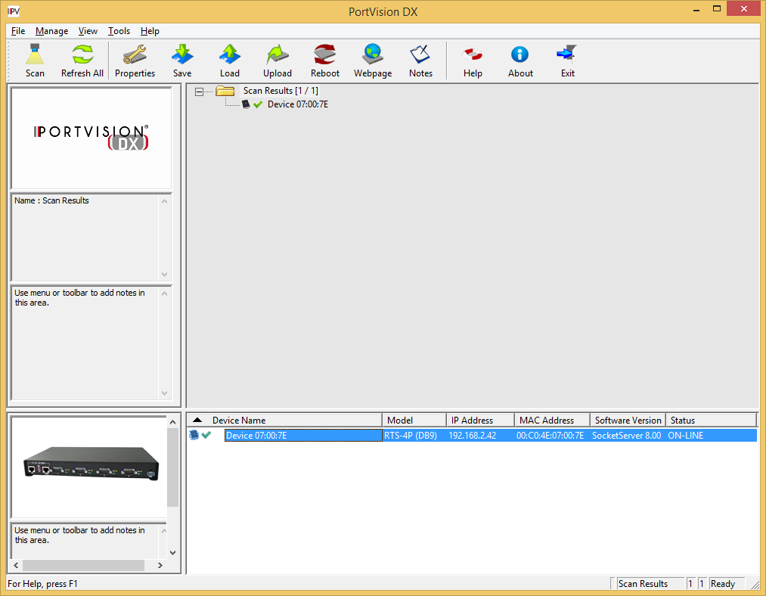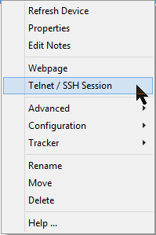
Device List Pane
Device Tree Pane
Right click on the DeviceMaster in the Device List Pane. Select Telnet / SSH Session from the pop-up

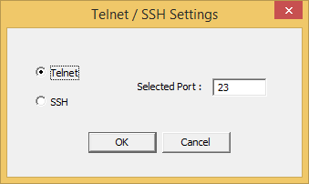
Leave the default settings and click the OK button. When prompted for a password, press enter as there is
no default password.

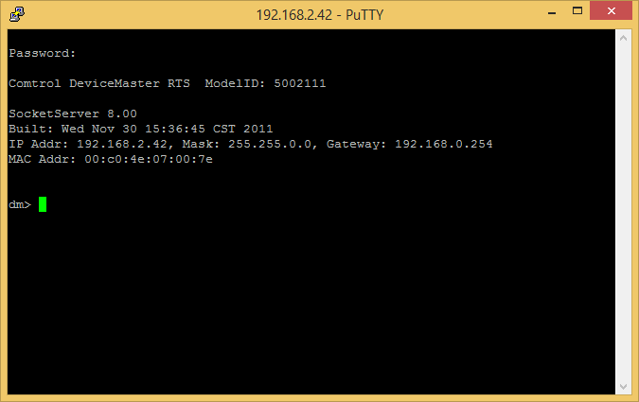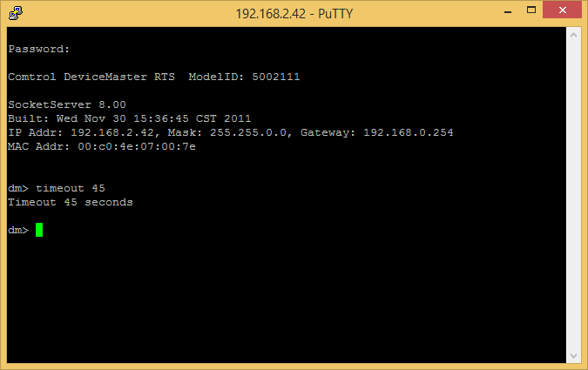
At the dm> prompt enter “timeout 45” (without quotes) and press Enter. It should echo back ‘Timeout 45 seconds’ and go back to the dm> prompt. Enter “q” (without quotes for quit) and Press Enter. This will close the PuTTY window.

Updating the Firmware
Back to top

This procedure is based on the DeviceMaster being directly connected to the PC using an Ethernet cable. A standard straight-through patch cord connected to the PC will be required. If the DeviceMaster has both an UP and DOWN Ethernet port, connect the Ethernet cable to the DOWN port which has a crossover built into it. If the DeviceMaster has only a single Ethernet port, it is smart enough to detect the type of cable used.

Please note: The SocketServer and NS-Link firmware files have been incorporated into a single file (called socketserver-10.01.cmtl). By default, once loaded, the file will show SocketServer in both the web page and PortVision DX until a driver begins communication with this particular DeviceMaster.

Once a driver establishes communications, the firmware will now immediately indicate that it is NS-Link without the driver having to upload a different firmware file to the DeviceMaster, or the DeviceMaster being rebooted, as in the past. This provides much faster driver initialization and recovery times.

If SocketServer does not change to NS-Link, then a driver loaded in the PC is NOT in communication with the DeviceMaster and may require configuration changes to be applied in the Driver Management Console discussed later in this guide. (Additional information is included in the Firmware_ReadMe.txt)

Return to PortVision DX.
Your line item (highlighted entry in the Device List Pane) may be slightly different depending on the hardware, version of software, IP address assigned, etc.
Highlight the line item in the Device List Pane and select the 'Upload’ icon from the launch bar.
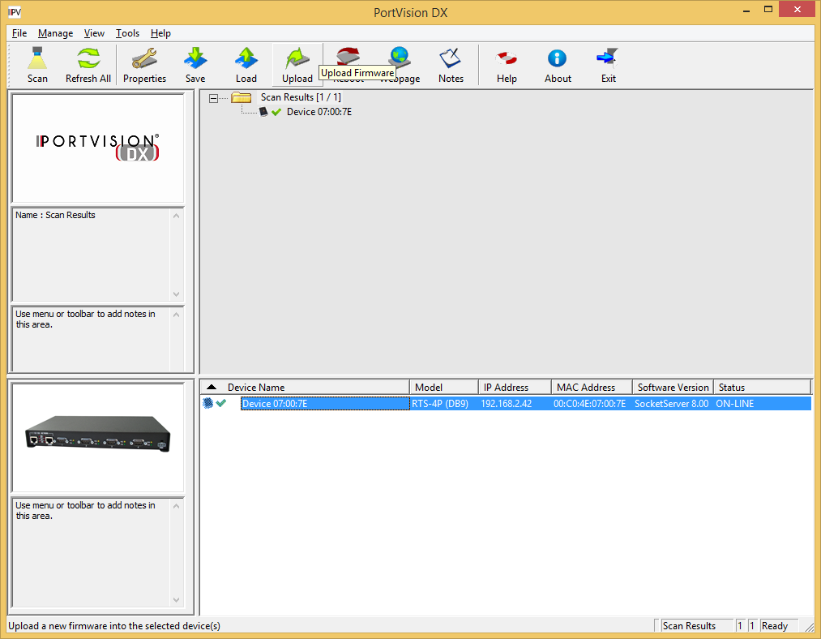
Device List Pane
Device Tree Pane
With the mouse hovering over the ‘Upload’ icon you will see displayed Upload Firmware

Path out to the Socketserver-11.30.cmtl file location. (\devicemaster_1206_package\3-Binaries\SocketServer\ Socketserver-11.30.cmtl)
NOTE: Upload the Socketserver-11.30.cmtl file FIRST! This is critical!
Select 'Open'
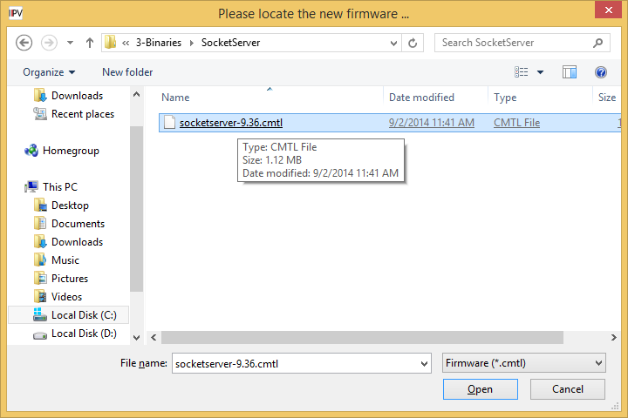

Read the confirmation message and select 'Yes'
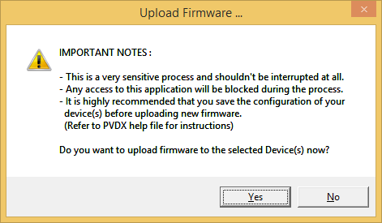

During this process you may receive notifications from the Windows Operating System that
the Ethernet connection has been lost or that a network cable is unplugged.
This is normal and expected so please disregard these notices.

During the process of PortVision DX uploading the firmware you will see several pop-up dialog boxes informing you of the state of the process.
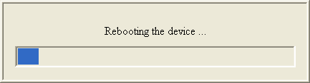

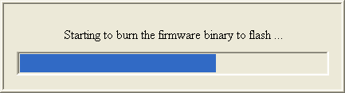

Once uploading has completed successfully, the following screen will show.
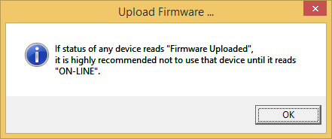
Click 'OK'

If you now right click on the DeviceMaster and select “Refresh Device” from the pop-up menu, you may see the Software Version show a version of Bootloader. If this version is prior to 4.22, then the Bootloader file should also be updated.
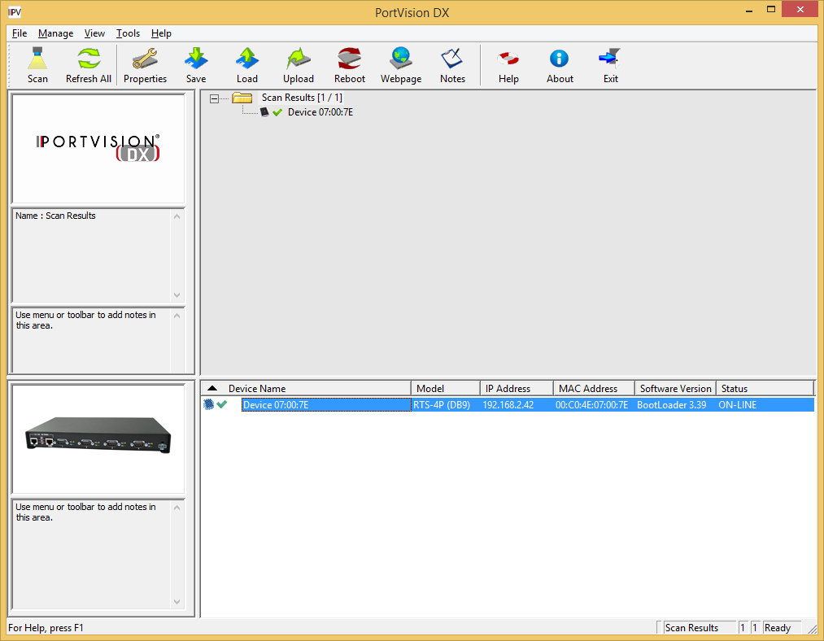
Device List Pane
Device Tree Pane
By default PortVision DX will only refresh itself every 120 seconds. You may manually “Refresh Device” as often as you like in order to see Bootloader displayed with its version number. If SocketServer is shown before you determine the version of Bootloader, you may want to reboot the DeviceMaster and begin refreshing once again.

Once the Socketserver-11.30.cmtl has uploaded you should see this screen. Note the highlighted line item details. The Software Version column should now indicate SocketServer 11.30 and the status should be ON-LINE. Refresh as necessary until the updated SocketServer is shown.

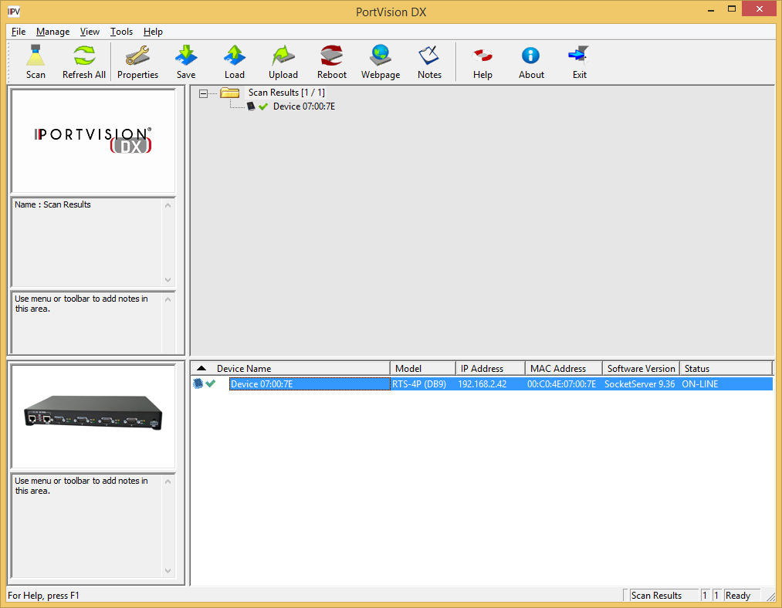
Device List Pane
Device Tree Pane

If the upload failed for any reason, repeat the process for Socketserver-11.30.cmtl until success is achieved.
NOTE! If the Socketserver-11.30.cmtl upload failed for any reason DO NOT ATTEMPT TO LOAD BOOTLOADER!
Immediately call Comtrol Technical Support at 763-957-6000 for instructions.
If the upload was successful, continue to the next step.

The procedure for uploading Bootloader is exactly the same as done with SocketServer. The only difference will be the name of the file selected for uploading.

Uploading of Bootloader should only be done when the DeviceMaster is directly connected from the network port on the DeviceMaster to the network port on the PC. Failure to do it in this manner may result in a DeviceMaster that is no longer usable and would need to be returned to Comtrol for reflashing. This is not the case with SocketServer. Do not attempt uploading Bootloader across a WAN or wireless connection under any circumstance. If you find yourself in a situation where firmware needs to be updated and when you cannot connect directly, you may see another method designed for this in the document downloaded from this link:
ftp://ftp.comtrol.com/contribs/devicemaster/help_files/tftp_firmware_update_instructions.pdf

Highlight the line item in PortVision DX as seen above and select 'Upload Firmware’ from the launch bar.
Path to the bootloader-4.31.cmtl file. (\devicemaster_1206_package\3-Binaries\Bootloader\bootloader-4.31.cmtl)
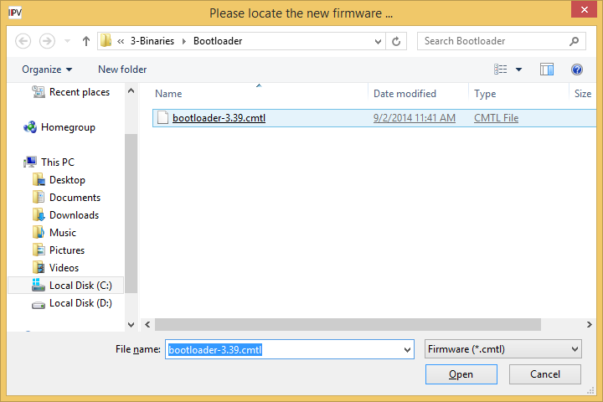
Click 'Open'

Read the confirmation.
Click 'Yes'

During this process you may receive notifications from the Windows Operating System that the Ethernet connection has been lost or that a network cable is unplugged.
This is normal and expected so please disregard these notices.

During the process of PortVision DX uploading the firmware you will see the pop-up dialog boxes informing you of the state of the process.

Once completed the following screen will show.
Click 'OK' and you will be returned to PortVision DX.
Firmware Updates are now complete for this DeviceMaster.
Repeat for additional DeviceMaster’s as necessary.
Resetting the Timeout Value in the DeviceMaster to 15 seconds
Back to top

Highlight the line item as shown in the Device List Pane.
Device List Pane
Device Tree Pane

Double click on the DeviceMaster to open the Device Properties page.
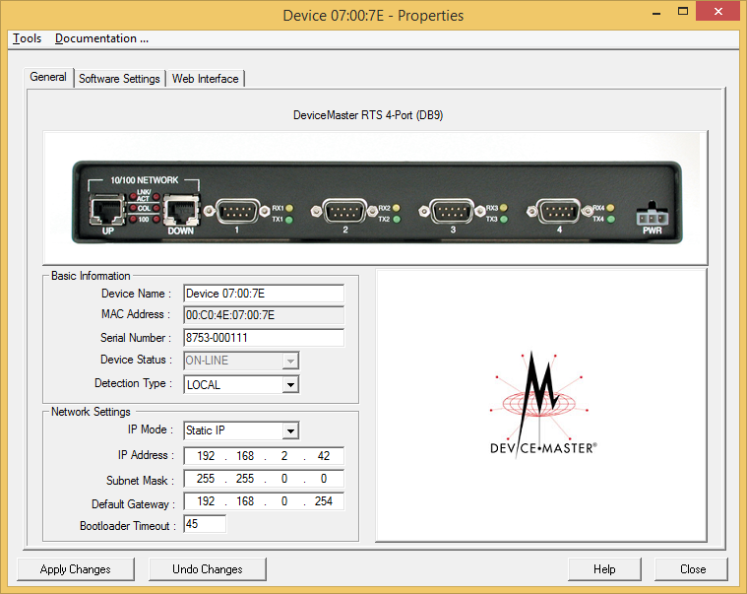
Change the Bootloader Timeout value to 15. (Optional: Setting this value to 1 will speed up booting and recovery times in the event of a reboot of the DeviceMaster.) This value must be set to a minimum of 15 seconds in order to be able to upload firmware to the unit.

Click “Apply Changes” and “Close”. The new Bootloader Timeout setting will take effect on the next reboot of the DeviceMaster.

Repeat for additional DeviceMasters as necessary.

You may now reset the BootLoader Timeout to the default of 15 if desired.

Driver Wizard Installation
Back to top

Driver Installation Setup

Install the driver wizard.

Legacy IPv4 driver: Run the DeviceMaster_Windows_12.06.exe (\devicemaster_1206_package\4-Driver\ DeviceMaster_Windows_12.06.exe). This will create a directory at C:\Program Files\Comtrol\DeviceMaster and extract the files to this folder. A Comtrol>DeviceMaster Program Group will be created with a shortcut to the Driver Installation Wizard and the DeviceMaster Driver Management Console for use after the initial driver install. Version 12.06 is the last release of the legacy IPv4 driver.

Current IPv4/IPv6 driver: Run the DeviceMaster_Windows_WSK_3.02.exe (\devicemaster_1206_package\4-Driver\ DeviceMaster_Windows_WSK_3.02.exe). This will create a directory at C:\Program Files\Comtrol\DeviceMaster and extract the files to this folder. A Comtrol>DeviceMaster Program Group will be created with a shortcut to the Driver Installation Wizard and the DeviceMaster Driver Management Console for use after the initial driver install.

If upgrading from legacy driver 12.06 to WSK 3.02, it is strongly recommended to completely uninstall the legacy 12.06 driver before installing the current WSK 3.02 driver.

Note: If installing multiple DeviceMasters for the first time (not updating the drivers), all of the DeviceMaster units may be selected and installed and then you may go to the Start Button>All Programs>Comtrol>DeviceMaster>Comtrol Drivers Management Console to configure the different units.

The installer will begin
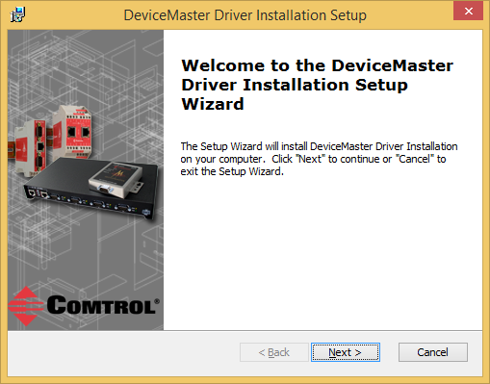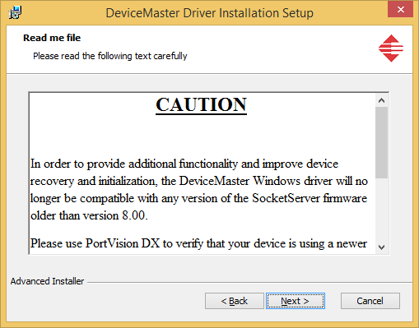
Click “Next” Please read the entire message and Click “Next”. This
version of driver is NOT compatible with any version
of SocketServer prior to version 8.00

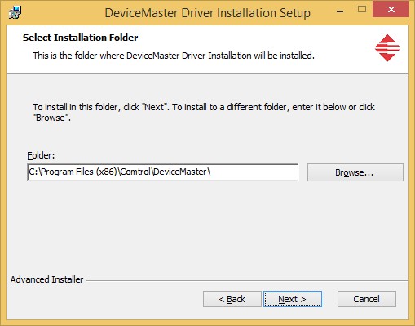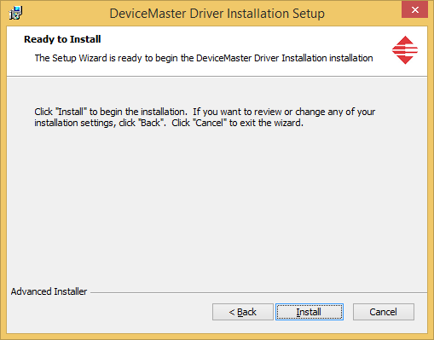
Accept the default and Click “Next” Click “Install”

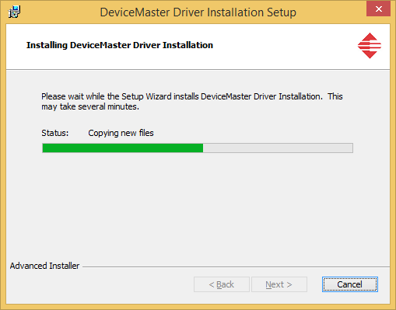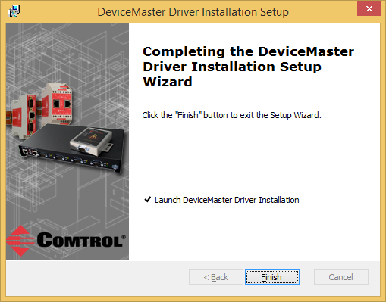
Files will now copy. Click “Finish”

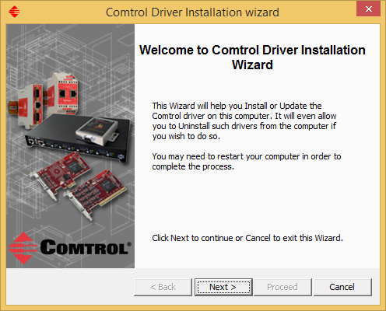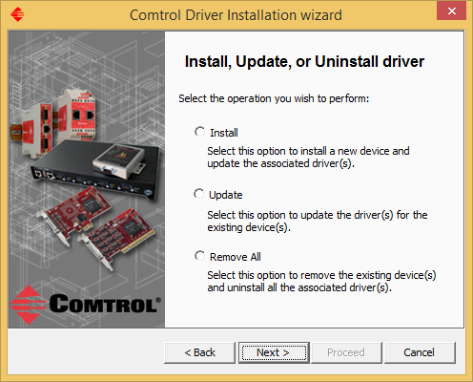
Click “Next” Select the process you wish to follow
“Install” a new DeviceMaster driver
“Update” a DeviceMaster driver
“Remove All” DeviceMaster drivers
Options:
Use the “Install” option when this is a new installation and there are currently no installed DeviceMaster’s

Use of the “Update” option when updating a previously installed driver prior to version 10 of the driver is not recommended. Version 10.xx of the driver has undergone extensive changes from previous versions and is not compatible with previous major versions. Updating from version 10.01 to 11.xx is OK.

Use the “Remove All” option when the pre-existing driver is less than version 10.xx
(ex: if version 9.99 of the driver is currently installed and version 11.08 is to be installed, it is necessary to uninstall version 9.99 before installing version 11. After removing the pre-existing driver a reboot of the PC will be required. You may then return to the DeviceMaster Driver Installation Wizard from the Start Button>All Programs>Comtrol>DeviceMaster program group and proceed using the “Install” option.
When removing your DeviceMaster with the intent of reinstalling the drivers, document the following basic information from each DeviceMaster found in Windows DeviceManager>Multi-port serial adapters.
1) The MAC address
2) The IP address
3) The Com Numbers assigned with the appropriate ports settings (RS-Mode etc as seen in the com port properties).
This information will be used to configure the new drivers to maintain the same MAC, IP and port settings to avoid having to re-arrange serial cables or change settings in your application.

Install a New Comtrol Device
Back to top

Please note: All serial port application software must be stopped. Using the wizard to install new DeviceMaster units will interrupt serial communications on drivers that are currently installed and serial data will be lost.

In this example we will be installing 1 DeviceMaster RTS 1 Port unit, 2 DeviceMaster RTS 4 Port units
and 3 DeviceMaster RTS 8 port units.

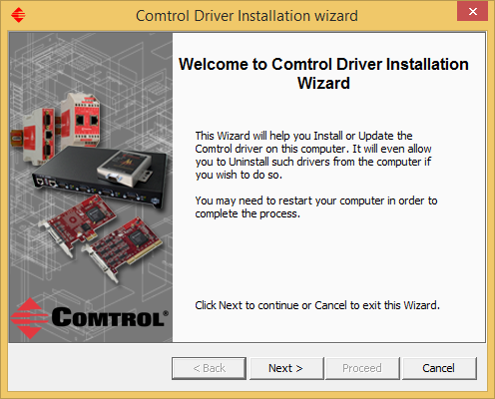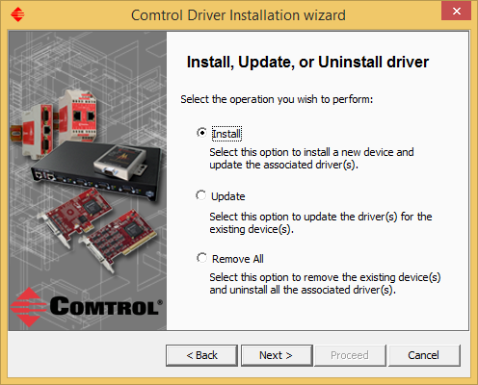
Begin by opening the Comtrol Driver Installation Wizard if not started from the selected option of “Launch DeviceMaster Driver Installation earlier. From the Start button: Start>Programs>Comtrol>DeviceMaster>DeviceMaster Driver Installation Wizard and click “Next>” and select Install from the options.

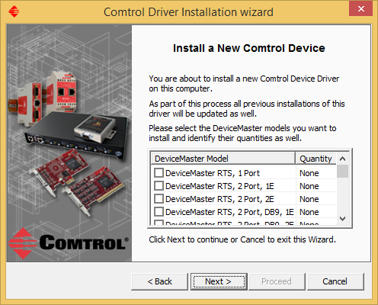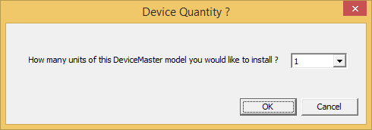
Click the box for the DeviceMaster 1 port to be installed Click on the drop down arrow and select the quantity
from the list. (up to 20)

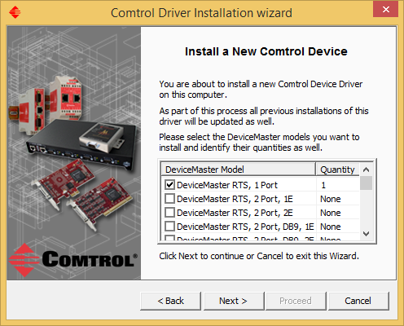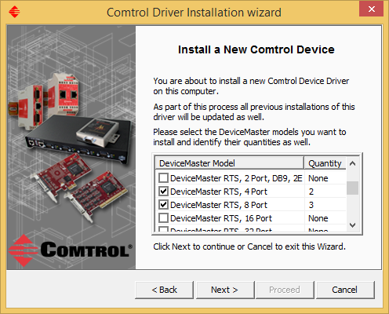
As seen here, 1 DeviceMaster RTS 1 Port unit is to be From this screen we can see that we have also selected
installed. Repeat for each model and quantity to be 2 DeviceMaster RTS 4 Ports units and 3 DeviceMaster RTS
added. We will install both 4 port and 8 port models 8 Port units. Once all of the models and quantities have
in this example. been selected, Click “Next”.
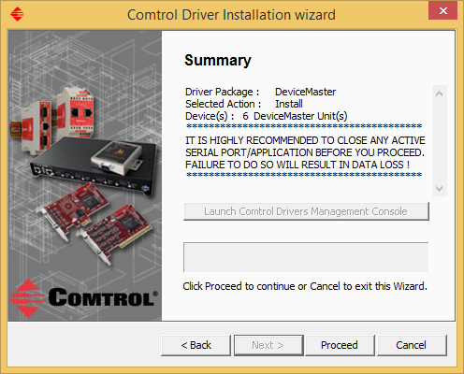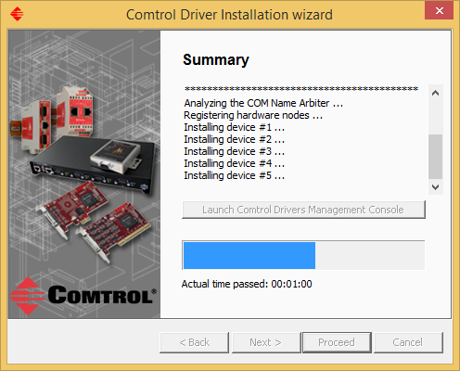
A confirmation page showing the total number of Each device node will be registered
DeviceMaster units to be installed. Click Proceed Registering hardware nodes for device #1…
Registering hardware nodes for device #2, 3, 4, 5 (shown)
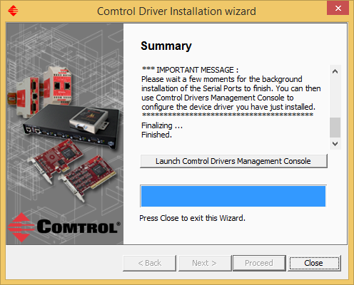 Go to Configure a DeviceMaster for Operation
Click the “Launch Comtrol Driver Management Console” to configure the DeviceMaster(s). If prompted by the system to reboot, it is recommended you do so. You may click on Close and start the Comtrol Driver Management Console manually from the Start>Programs>Comtrol>DeviceMaster>DeviceMaster Driver Management Console

Update One or More DeviceMaster Drivers
Back to top

In the event that a newer driver is available and you wish to update your driver, you may download and install the new driver. Once installed the Comtrol Driver Installation wizard will present you the option to “Update” the driver. This will update all DeviceMaster drivers installed in this PC without affecting any configuration settings. Once the update procedure is completed you may then install your new DeviceMaster units.
Please note: All serial port application software must be stopped. Using the wizard to update DeviceMaster units will interrupt serial communications and serial data will be lost. Be sure to close the application.

Use of the “Update” option when updating a previously installed driver is not recommended. Version 10.xx of the driver has undergone extensive changes from previous versions and is not compatible with previous major versions.
(ex: updating driver version 9.xx to 11.xx should not be done. Updating from version 10.02 to 11.xx is OK.)

Start the driver wizard from the Start Button>Programs> Select “Update”
Comtrol>DeviceMaster>Driver Installation Wizard

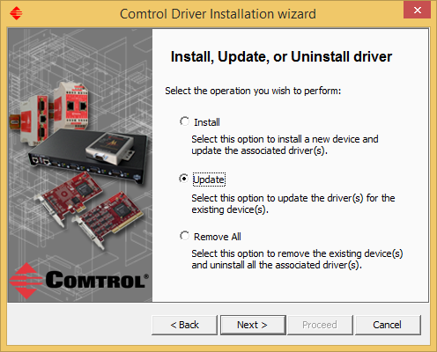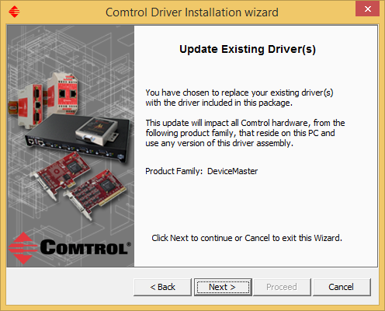
Click “Next” Confirmation page: Click “Next”
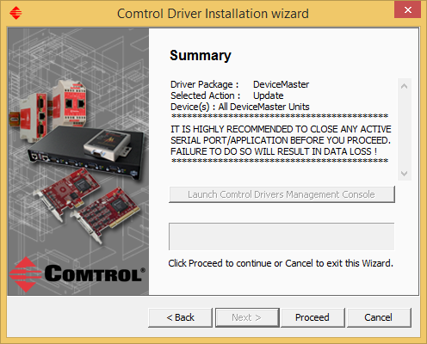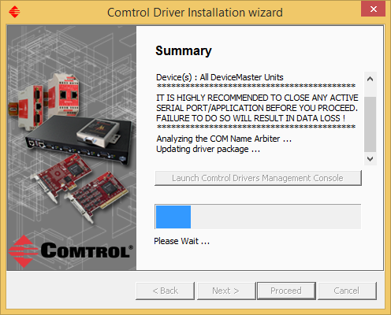
Click on “Proceed

Please be patient. Depending on the PC and the number of DeviceMaster units and serial ports to be updated, this process may take an extended period of time. It is not uncommon for up to 1 minute per port to be required on slower systems.

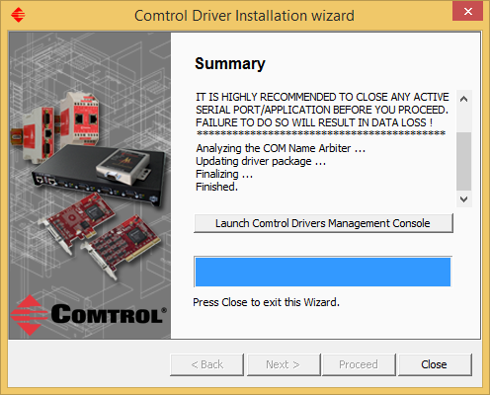
Click “Close” to exit the wizard, or if desired, click the button to “Launch Comtrol Driver Management Console”
to modify configuration settings if necessary.

Remove All DeviceMaster Devices and Drivers
Back to top

If you have a pre-existing driver that you wish to remove, use these instructions.

When removing your DeviceMaster with the intent of reinstalling (not simply updating) the drivers, start by getting the following basic information from each DeviceMaster found in Windows DeviceManager>Multi-port serial adapters. 1) The MAC address, 2) The IP address, and 3) The com numbers assigned with the appropriate ports settings. This information will be used to configure the new drivers to maintain the same MAC, IP and port settings to avoid having to re-arrange serial cables or change settings in your application. Updating an existing driver will not interfere with these settings. It is highly recommended NOT to use the update procedure with drivers prior to version 11.XX due to the new features in this driver/firmware combination, but instead, removal of pre-existing drivers and a fresh install of this driver is strongly recommended.

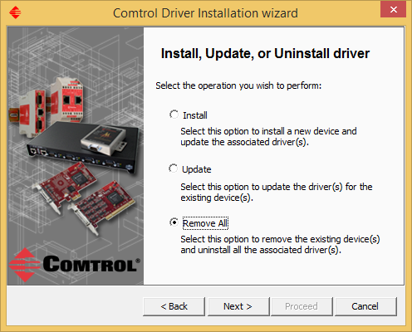
This is the removal of a pre-existing driver, so select the Click Next
Option to “Remove All”

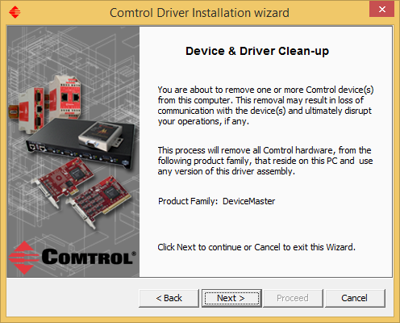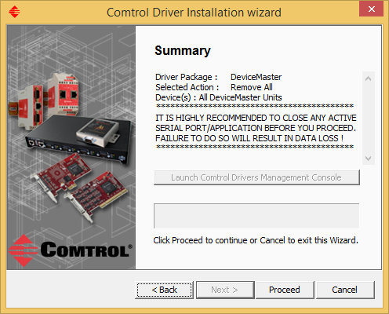
Information page. Click “Next” Confirmation page: Click “Proceed”

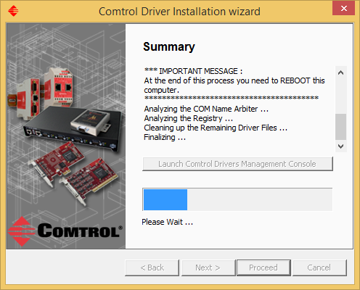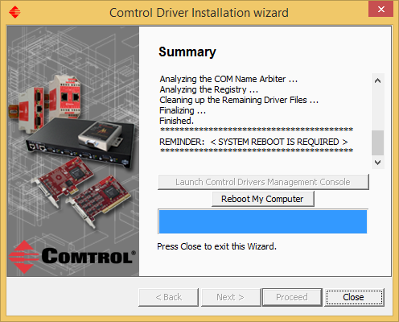
Summary page Click the “Reboot My Computer” to reboot now.

Click “Close” to exit the wizard and manually reboot the PC later.

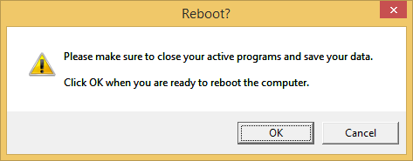
Click OK to reboot. Click “Cancel” to manually reboot the PC later.
(The PC must be rebooted before new DeviceMaster drivers are installed.)

In the event that there are issues in the PC that would require a manual driver removal (usually on the advice of your Technical Support Representative) see the file located at this link: ftp://ftp.comtrol.com/contribs/devicemaster/help_files/manually_remove_all_devicemaster_devices_and_drivers.pdf
This will provide a much more comprehensive and detailed instruction manual for the removal of all references of DeviceMasters in the PC than seen in this document.

In most cases using the Driver Installation Wizard “Remove All” process is sufficient.

Configure a DeviceMaster for Operation Using the Comtrol Driver Management Utility
Back to top

This version of the driver no longer uses Windows DeviceManager to configure the DeviceMaster(s). The DeviceMaster will now be managed using the Comtrol Drivers Management Console, found in the Comtrol Programs Group.

This Comtrol Driver Management Console may be started from the option at the end of the Driver Installation Wizard, or from the Comtrol Program Group in the Start button (Start > All Programs > Comtrol > DeviceMaster > DeviceMaster Driver Management Console), or from Windows Control Panel.

Once started you may see something like this example which has the DeviceMaster units that were installed earlier on page 20. Each DeviceMaster is a separate entity and will be configured individually. This example will only be concerned with the first unit listed. In this example this is the DeviceMaster RTS 1 port and each will follow this same procedure.

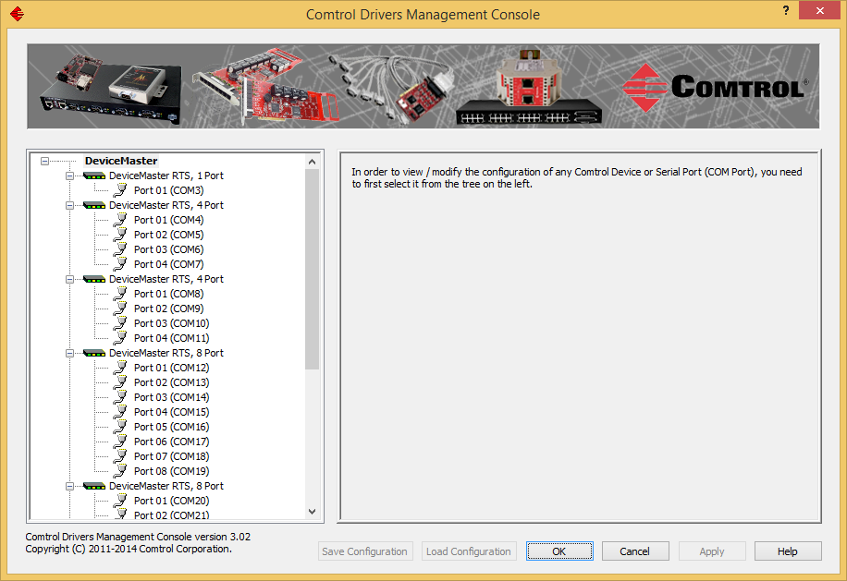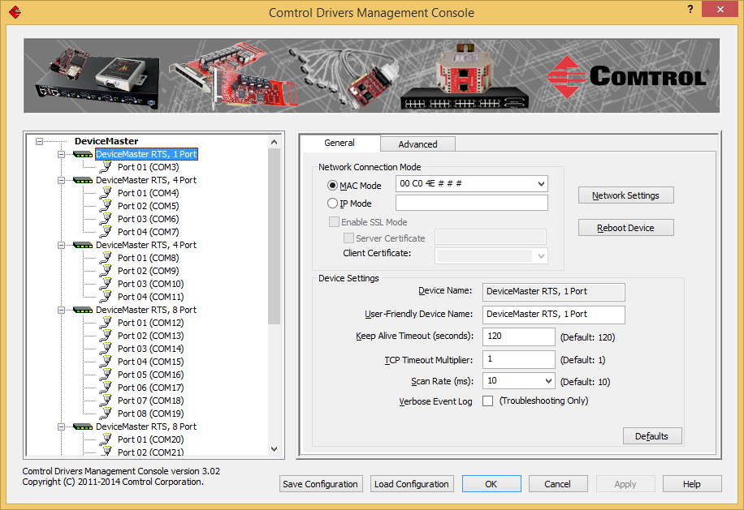
A DeviceMaster has not yet been selected. Click on the DeviceMaster to get the “General” tab.

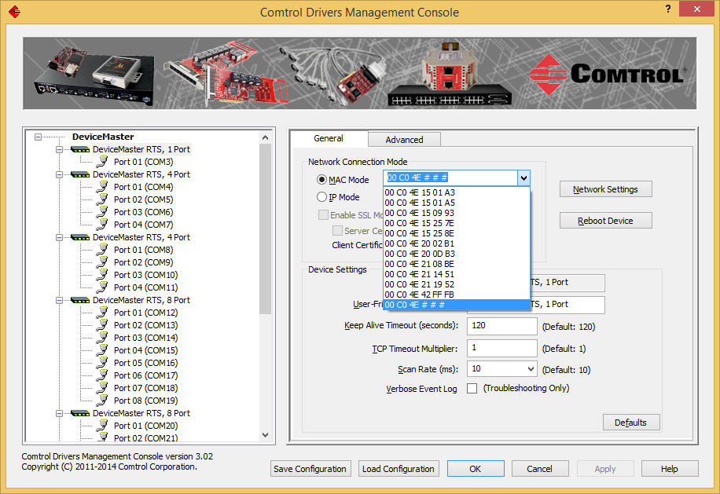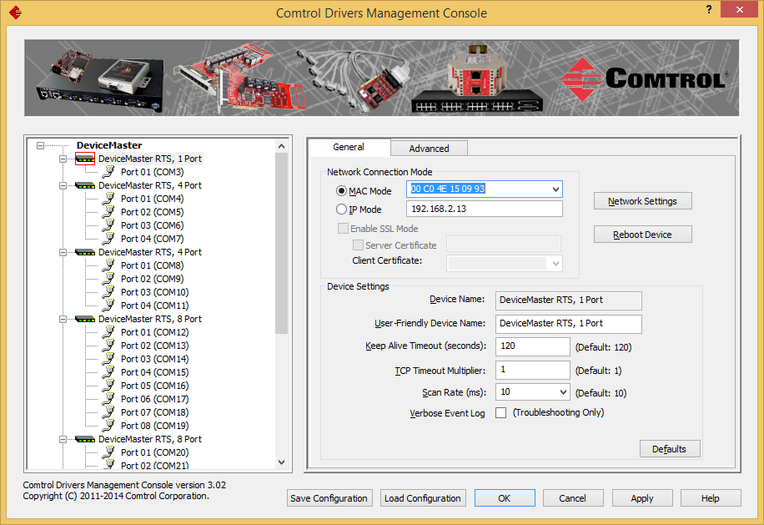
Click the drop down arrow next to the 00 C0 4E # # # Once selected the address will appear in the MAC Mode
MAC address to display the list of MAC addresses that address window and a ‘red box’ will around the icon in the
are discovered on this local Ethernet segment and select left panel. This indicates the “Apply” button has not been
the appropriate MAC address. This system shows 11 clicked. The IP Address of the DeviceMaster will be
available DeviceMaster 1 Port units. displayed in the IP Mode field.

If the MAC address is not displayed, manually enter it. The installation of the correct MAC address is critical even if the “IP Mode” will be selected later as the MAC information is required for proper “Advanced” tab “Device Status” messages to be displayed. (If the MAC address is not displayed in the Drop Down list, this may indicate a problem if the DeviceMaster is on the local segment. (You may want to call Comtrol Technical Support to help resolve this.)
Until the “Apply” button is clicked, any changes made are not saved and the red box will be visible.
Clicking “OK” will apply (save) the changes and close the Comtrol Management Utility.
Clicking “Cancel” will discard the un-applied settings and close the Comtrol Management Utility.
It is recommend to click the “Apply” after each change made.

We have changed to the “Advanced” tab and see in the
Device Status window that a DeviceMaster cannot Return to the “General” tab and enter the MAC address.
be detected as the MAC address has not yet been applied. Click the “Apply” button
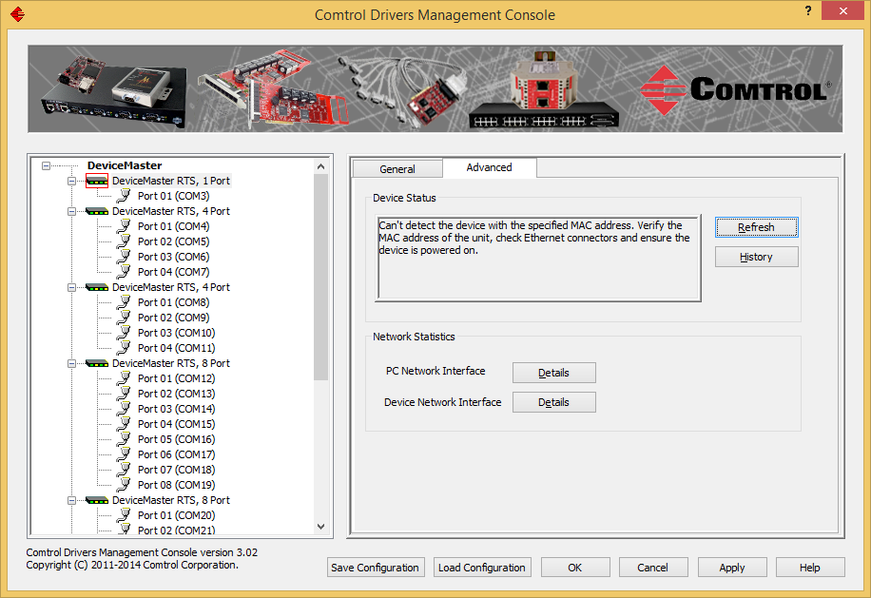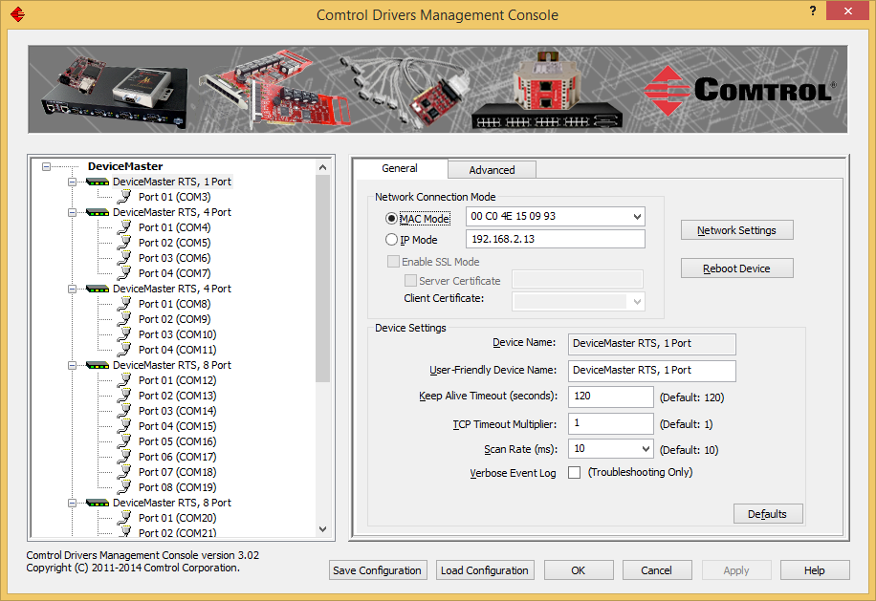
Now the changes have been applied and the “red box”
is no longer seen on the icon.

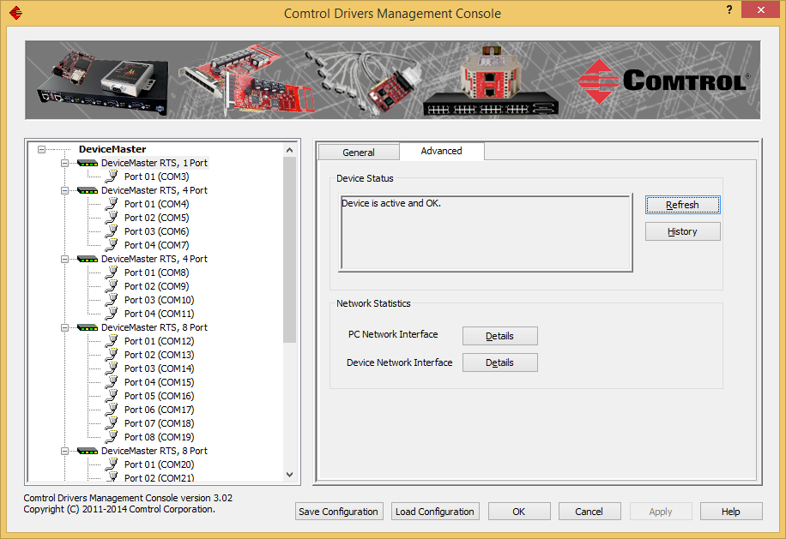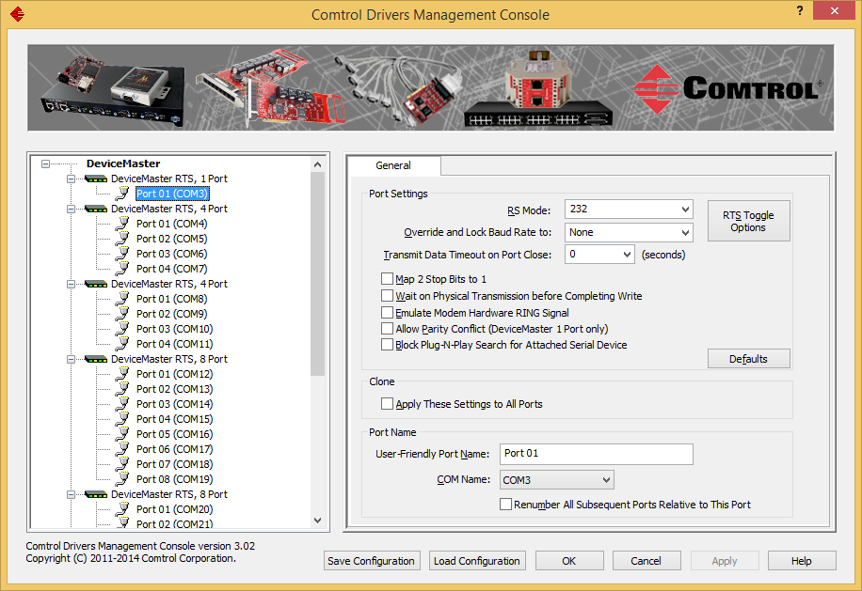
If we return to the Device Status, the condition should be We may now select the serial port and configure these
seen as “Device is active and OK”. properties as desired.

If the DeviceMaster is going to be used on a remote network, it will be necessary to change from MAC mode to IP mode.
Select the IP Mode, and click “Apply” button. (If you are considering the use of the Secure Data transfer method (Enable SSL Mode) see the DeviceMaster User Guide for these instructions.)

Repeat for each DeviceMaster as necessary. Once you are finished with all of your configuration changes, click the
“OK” button which will close the Comtrol Management Utility.

If you have not already closed the Driver Installation Wizard, you may now do so.

If your system presents a pop up message recommending that the PC be rebooted, please do so.

Test your DeviceMaster Serial Ports
Back to top

Test the serial ports using the Test Terminal app in PortVision DX and the Comtrol supplied Loopback plug provided with the hardware. If the testing does not complete successfully, then I recommend that you give our tech support group a call at 763-957-6000.
If you need to create a loopback plug you can download the instructions at http://downloads.comtrol.com/contribs/devicemaster/help_files/Loopback.pdf
Comtrol's utilities for Ethernet connected products are included with the PortVision DX application from the 'Tools' menu.
Stop all applications that may be accessing the ports such as RAS, RRAS or any faxing or production software. See the appropriate manuals for instructions on stopping these services or applications. If another application is controlling the port, then Test Terminal will be unable to open the port and an error message will be shown.
Remember to restart the application once testing of the ports has been completed.
Testing The Comtrol ports.
1a.) From the 'Tools>Applications' drop-down menu in PortVision DX, select Test Terminal (WCOM2))
2a.) Port>openport>ComX (where X is the com port number to test)
3a.) Attach the Comtrol supplied loopback plug onto the serial port of the controller
4a.) Port>openport>send test data
5a.) You should see the alphabet scrolling across the port. If so, then the port installed properly and is operational.
6a.) Port>openport>send test data (data should stop)
7a.) Port>openport>loopback test (This is a pass fail test and will take a second or two to complete)
8a.) Repeat for each port that needs testing.
9a.) Close test terminal
If both of these tests successfully complete, then the port is operational as expected.
Close Test Terminal and start the application that will be using the serial ports.
There are, as you have seen, two tests in the Test Terminal and I will describe both.
Send Test Data: The is simply sending data out the transmit line to the 'Loopback' plug which has the transmit and receive pins connected thus sending the data back through the Receive line to the Test Terminal app which then displays the received data in the terminal window for that port. The send test data test is only testing the transmit and receive signal lines and nothing else. This test will work in either RS232 or RS422 modes as both modes have transmit and receive capability. A failure in this test will essentially prevent the port from working in any manner.
Loopback Test: This test using the Comtrol supplied loopback is testing all of the modem control signals, RTS, DTR, CTS, DSR and CD. When a signal is made HI in one line the corresponding signal line will indicate this. The Loopback test changes the state of the lines and looks for the corresponding state change. It will then send certain commands and confirm the transmission and receipt of these commands. If it successfully recognizes all of these changes, the port passes. A failure on this test is not necessarily critical, as it will depend on what is connected and how many signal lines are in use. For example, if you are using RS232 in 3-wire mode (Transmit, Receive and Ground) a failure will cause no discernable issue since the other signals are not being used. If the port is configured for use as either RS422 (or with some products RS485) this test will fail and is expected to fail since RS422 (and RS485) do not have the modem control signals that are present in RS232 that this test is designed for.

Instructions Revision History
Back to top

V12.06
Add Bootloader 4.31
Add PortVision DX 4.09
Clarify phrasing of Legacy IPv4 12.06 vs Current IPv6/IPv4 3.02

V12.03
Added Bootloader 4.30

V12.02
Added PortVision DX 4.08

V12.00
Added PortVision DX 4.05
Added section for determining which version of PortVision DX to use
Updated text for new version.

V11.10
February 15, 2017
Replaced Bootloader 4.22 with Bootloader 4.25
Updated text for new version.
Frozen. Version 12.00 will include the new DX4.05 with PortVision DX 3.05

Kurt Rees
kurt.rees@comtrol.com
Technical Support

